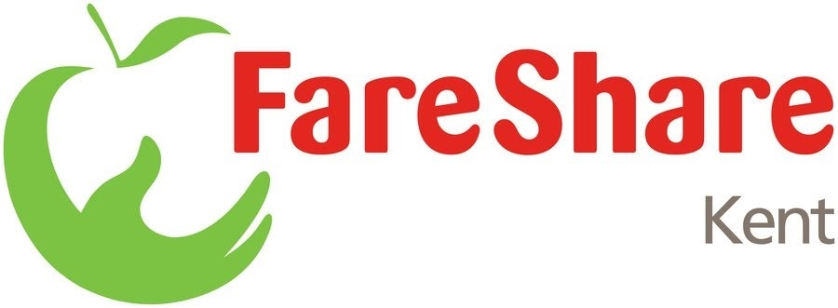

Regional Sourcing Officer

Accountable to: Operations Manager.
Salary: £12,909
Hours: 18.75 hours per week

Summary of Role
Working to the Operations Manager the postholder will be required to maintain existing and develop new relationships with food partners and food industry stakeholders across the Kent region. The key objective will be to identify and effectively access extra food volumes that can underpin and support the future growth of FareShare Kent. The acheivement of any growth must be delivered to the highest standards of food hygiene and health & safety.

Duties & Key Results Areas
Key duties will include:
- Research and develop new relationships with food partners and food industry stakeholders across Kent
- Meet potential new food partners to competently and effectively present the benefits of working with FareShare Kent
- Build strong relationships and engage with food partners and stakeholders on a regular basis
- In creating partnerships ensure the highest standards in regard of food hygiene and general health and safety are maintained at all times
- Create a food partner portfolio, also acting as its main point of contact
- Work closely with the FareShare Kent team to discuss food availability and co-ordinate logistical arrangements to collect available foods as necessary
- Maintain ongoing record relating to receipted food volumes as received from both existing and new partners including the breakdown of product types as obtained
- On a regular basis, capture feedback from our food partners about their relationship with FareShare Kent identifying as necessary how improvements in our service can be achieved
- Attend monthly meetings as scheduled by the Fareshare Kent Operations Manager providing a full overview of food receipted progression as achieved through the establishment of existing and new food partnerships.

Person Specification

Essential
- Good organisational skills and the ability to prioritise workloads, whilst maintaining an excellent attention to detail
- The ability to develop and maintain effective working relationships with external food partners and the FareShare Kent team
- A team player with an enthusiastic, positive and collaborative attitude to achieving work objectives and a desire to find tangible solutions to matters which may arise
- A commitment to excellent customer service
- Excellent communication skills
- Computer literate including a good working knowledge of Microsoft Office and Excel
- Own car with current clean driving license;

Desirable
- Experience of working in partnership with other organisations
- A level 3 qualification in food hygiene
- Food sector experience

